Online discussions and information for AOC members

During the lockdowns around the world and subsequent periods in socially distanced “bubbles” at home, many members have been spending time fettling their cars and also looking for guidance and support online. It has also been interesting to see an increase in posts in the AOC Facebook group about members’ activities during this period, when it has been difficult to attend any events or gatherings in person.
Many AOC members are quite new to the world of online social media and how to use it.
Did you know that the AOC has two very helpful online support sites? Do you know how to access them and what the differences are?
1: The Forum on the AOC website (www.alvisoc.org)
The Club has had a repository of useful technical information for many years, and the new Forum on the AOC website replaces the old Bulletin Board (click www.alvisoc.org/boards). The Forum is intended to be a library of useful technical support, feedback on suppliers’ services or products, a facility for members to buy and sell parts (in addition to the Calendar), and any other general information or comments that members would like to share.
The Forum differs from the AOC Facebook Group in that the Forum is a permanent repository of information, so if you have an issue, you can search the Forum and see if other members have had similar issues in the past. The Forum has retained all the information and posts from the previous Bulletin Board, so it has information going back for many years with over 2,500 posts from members.

The AOC web Forum can help you sort this out online!

The Forum is part of the AOC website, www.alvisoc.org, and is divided into five main areas:
i: Announcements and Information: used for posts about the Forum.
ii: General: used for any non-technical topic. Members can use this section for comments about the AOC, the Alvis Centenary, the FHBVC or other general items of interest.
iii: Supplier Feedback: your comments on services, products for Alvis - recommendations are welcome.
iv: For Sale and Wanted: used for selling or looking for parts (cars should be advertised in the Calendar and in the main website)
v: Technical: this is probably the most useful section and is used for technical topics, hints, problem-solving and advice. This section is divided into sub-forums for specific models (e.g. Speed models, TD/E/Fs) - the information goes back many years and is fully searchable.

To access the Forum, click on “Forums” from the menu on the website homepage (see screenshot below), and the Forums page will come up showing the various Forum sections. To go to a specific forum topic, click on the heading in the second column. This will take you to the page related to that topic where you can view the various posts.

The Forum is public to view, but only members can contribute or post to the Forum. To do so, you must log in to the website as a member to make a Post, using your email address and password as registered with the Club. If you try an add a ‘New Topic’ without logging in, the application will take you to the Login page. You can login into the website at any time by clicking on ‘Log In’ which can be found at the top right of every web page (click www.alvisoc.org/login, see screenshot below).
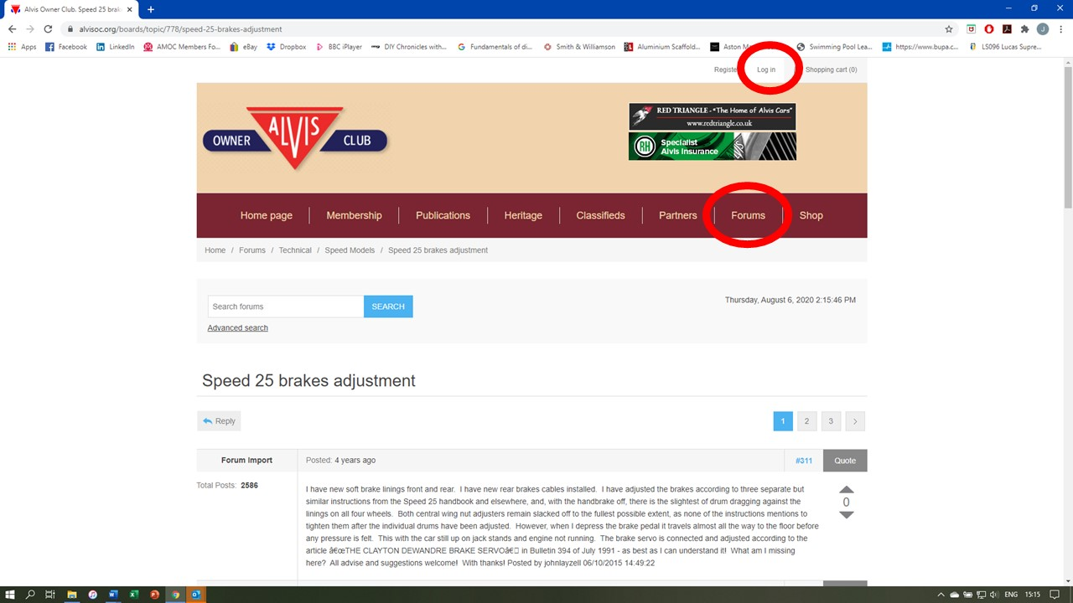
Screen shot from the AOC Forum showing an article on Speed 25 Brakes with may follow-up comments. The red circles show where to click for the Forum and also where to “Log in” for members’ only access.

If you have not logged on as a member to the AOC website before, you can do so using your default password which you were given when you joined or as part of your membership renewal. Once logged in with the default password, you can the change your password to a new personal password of your choice by clicking on “My Account” and then choosing the “Change password” option.” You can click “remember me” when you log in, so you don’t have to put in your password every time you access the AOC website.
If you don’t know your default or personal password, please email Richard Long, the Club’s IT Officer at itofficer@alvisoc.org.
The Forum is a fantastic facility with over 2,500 useful posts, and all members are encouraged to use it as much as possible, especially for technical issues, so that the information is retained on the Forum for other members’ reference in the future.

2: The Alvis Owner Club Facebook Group (www.facebook.com/groups/alvis.owner.club).
The AOC Group on Facebook (click www.facebook.com/groups/alvis.owner.club) provides the Club’s online social media activity, and although it can be viewed by the public, only AOC members can contribute to the Group and add articles, photographs or videos.
The Facebook Group is for members to share information, news, events and activities relating to Alvis and their cars. Although some members use Facebook to share technical information or to ask for advice, all the information on Facebook is temporary, so if you want the technical information or advice to remain permanent, please use the AOC website Forum.
The AOC Facebook Group has well over 300 members, who contribute regularly and share lots of very useful information, often on a daily basis. Members can comment, share experiences, or just “like” other members’ posts.
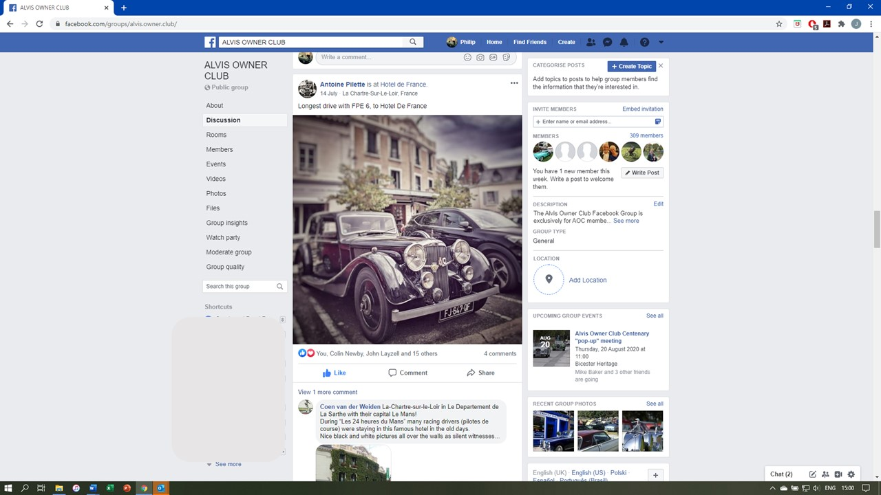
Screenshot showing an article and photos posted in the AOC Facebook Group.
To be part of the AOC Facebook group, you or your family member must first join Facebook and create an account - it’s free, go to www.facebook.com/r.php and enter a name, date of birth, email or phone number and create a password. A member of your family who is already on Facebook (perhaps one of the younger generations in your family) can join the Group providing they give your correct name and membership number when asking to join the Group.
After joining Facebook, you go to the AOC Group page (see above) and click “+ Join Group” under the main photograph on the Group homepage. You will then be asked to confirm your AOC membership number by answering the following question: “This is a closed/private Group for Alvis Owner Club members. Please reply and confirm your Alvis Owner Club membership number to join the Group. Thank you.”
Your membership number is then checked by one of the moderators of the Group, and then you are given access to contribute to the Group. If you don’t submit your membership number, you cannot join the group. If you are not an AOC member, the AOC will suggest you join the public Facebook group “Alvis Cars”.
So, please give both of these online facilities a try – they won’t work properly without member (your) participation.

